Chapter 6
Agile Modeling and Prototyping

Key Points and Objectives

1. Prototyping is an information-gathering technique useful for supplementing the traditional systems development life cycle.

2. Prototypes are useful in seeking user reactions.

3. There are four conceptions of prototypes:

A. Patched-up prototypes
B. Nonoperational scale models
C. First full-scale models
D. Prototypes which contain only some of the essential system features

4. Prototyping may be used as an alternative to the systems development life cycle.

5. Guidelines for developing a prototype are:

A. Work in manageable modules.
B. Build the prototype rapidly.
C. Modify the prototype in successive iterations.
D. Stress the user interface.

6. One disadvantage of prototyping is that managing the prototyping process is difficult because of its rapid, iterative nature. A second disadvantage is that incomplete prototypes may be regarded as complete systems. Clear communication of the prototype timetable with users is essential.

- One advantage of prototyping is the potential for changing the system early in its development. A second advantage is the opportunity to stop development on an unworkable system. A third advantage is the possibility of developing a system that closely addresses users needs and expectations.

- Sometimes COTS software may be the quickest way to create a prototype.

- Systems analysts must work systematically to elicit and evaluate users reactions to the prototype. There are three ways the user is involved:

A. Experimenting with the prototype
B. Giving open reactions to the prototype
C. Suggesting additions to and/or deletions from the prototype

10. Rapid application development (RAD) is an object-oriented approach to systems development.

11. There are three broad phases to RAD:

A. Requirements planning phase
B. RAD design workshop
C. Implementation phase

12. RAD is used when:

A. The team includes programmers and analysts who are experienced with it.
B. There are pressing business reasons for speeding up the portion of application development.
C. The project involves a novel ecommerce application and RAD gives a competitive advantage by producing results quickly.
D. Users are sophisticated and highly engaged with the organizational goals of the company.

13. Agile modeling is used to plan quickly, develop and release software quickly, and revise software quickly.

- There are four values that are important to agile modeling:

- Communication
- Simplicity
- Feedback
- Courage

- It is important to maintain an attitude of humility when doing agile modeling.

- The basic principles of agile modeling are:

- Satisfy the customer through delivery of working software.
- Embrace change, even if introduced late in development.
- Continue to deliver functioning software incrementally and frequently.
- Encourage customers and analysts to work together daily.
- Trust motivated individuals to get the job done.
- Promote face-to-face conversation.
- Concentrate on getting software to work.
- Encourage continuous, regular, and sustainable development.
- Adopt agility with attention to mindful design.
- Support self-organizing teams.
- Provide rapid feedback.
- Encourage quality.
- Review and adjust behavior occasionally.
- Adopt simplicity.

- The activities of agile modeling are:

- Coding
- Testing
- Listening
- Designing

- The four resource control variables in agile modeling are:

- Time
- Cost
- Quality
- Scope

- The four core practices in agile modeling are:

- A short release time
- Working a 40-hour week
- Having an onsite customer
- Pair programming

- An agile modeling process has the following steps:

- Listen for user stories from the customer.
- Draw a logical workflow model for the user story.
- Create new user stories based on the logical model.
- Develop some display prototypes.
- Use feedback from the prototypes and logical workflow diagrams to develop the system until a physical model is created.

- User stories are written that consist of a dialogue between developers and users.

- An agile modeling approach called Scrum is based on team development within a strict time frame.

- There are a number of lessons learned from agile modeling.

- There are seven strategies for improving the efficiency in knowledge workers:

- Reduce interface time and errors.
- Reduce process learning time and dual processing losses.
- Reduce time and effort to structure tasks and format outputs.
- Reduce nonproductive expansion of work.
- Reduce data and knowledge search and storage time and costs.
- Reduce communication and coordination time and costs.
- Reduce losses from human information overload.

- There are six risks involved when adopting a new information systems approach:

- The culture of the organization and the culture of the systems development team
- Timing
- Cost
- Clients reactions
- Measuring impact
- The individual rights of programmers and analysts

Consulting Opportunity 6.1 (p. 159)

Is Prototyping King?

Even though Paul and Ceil are enthusiastic about a prototype, it is still not advisable to develop one. The computerized warehouse inventory and distribution information system are very straightforward, and not suitable for prototyping because the outcome of the system as a solution is well-known and predictable. Furthermore, there is a tight budget. To justify prototyping, the novelty and complexity of the problem and solution must be considered. The environmental context for the system should also be evaluated when deciding whether to prototype. Systems that exist in a changing environment are good candidates for prototyping.

Help Paul and Ceil understand that their system can be successfully developed without a prototype. Tell them that prototyping is not necessary and would only slow down the whole project. Additionally, it would cost much more to prototype. The students should write a letter to this effect.

Consulting Opportunity 6.2 (p. 160)

Clearing the Way for Customer Links

The problem of designing a Web site for sale items lends itself well to either the patched-up prototype or the nonoperational prototype, but not to the first-of-a-series prototype or the selected features prototype.

The patched-up prototype would be useful because the system could be put together and used, and then modified without all the final features that would make it efficient, such as fast loading graphics or efficient data storage. The prototype could be modified and different combinations of Web elements could be experimented with.

The nonoperational prototype would also be useful to elicit feedback but without building the necessary database behind the Web site. The advantage of this type of prototype is the simplicity of creating the Web pages but without the complex coding required to maintain the Order and Customer databases.

The first-of-a-series prototype creates a full-scale model of the system, which would be replicated at different locations, which is unnecessary on the Web.

The selected features prototype may not be the best choice, because the full set of linked Web pages needs to be prototyped.

Consulting Opportunity 6.3 (p. 161)

To Hatch a Fish

As a fourth member, I would point out the importance of building the prototyping rapidly. One of the main purposes of a prototype is that it enables users to see and use the system early in the system life cycle instead of waiting for a finished system to gain hands-on experience. Sam must be egged on: no extra features should be added to the hatchery system before giving it to the managers to experience.

Getting early feedback allows successive iterations to more nearly approach user requirements. This iterative procedure will gain more user involvement and feedback early in the development, therefore more acceptance. On the other hand, if the prototype is delayed and cannot meet the deadline, users may become discouraged. They may lose faith in the systems analyst. However, there is one tradeoff: the managers may expect something more than just a basic system as a prototype.

Consulting Opportunity 6.4 (p. 162)

This Prototype Is All Wet

Based on Sandys observation of Wills reactions to the output, the following changes should be considered: (1) The formats of the output must be flexible enough to accommodate the needs of individual users. The current system is unwieldy. Users are not receiving the right kinds of information. (2) Routing of the outputs should be improved.

To calm Lathers fears about having the prototype “taken away,” explain that a prototype is not a finished product. On the contrary, it is an opportunity for users to experiment with it and suggest changes to meet their needs better.

It is necessary to communicate the purpose of prototyping to users to prepare them for its evolutionary use before it is tried. Users should understand that prototyping is only valuable when users are honestly involved and that changes are a part of the prototyping process. Lather should be convinced that he should not accept something less than what is needed.

HyperCase Experience 6

1. Make a list of the user stories Contessa Silverstone shared as examples.

“Instructors enter hours that they have worked and per diem expenses from a remote training site.”

“A training project, along with its milestones and tasks, may be initiated from any location.”

“When a new project that is not a training project has been added, the Training Unit will receive notification of the new project, including contact details.”

2. Locate the prototype currently proposed for use in one of MREs departments. Suggest a few modifications that would make this prototype even more responsive to the units needs.

Snowden Evans’ office

The prototypes currently proposed for use in one of MREs departments is located on the computer in Snowden Evans office. The prototype contains a main menu and menus for editing project information, performing queries, and for reports.

The following options are available:

Edit Menu | Query Menu | Report Menu
Edit Project/Milestones  Edit Milestones/Tasks  Edit Projects  Edit Milestones  Edit Tasks  Edit Assignments  Edit Requirements  Edit Resources  Edit Leaders | Query Projects and Milestones  Query Requirements  Query Milestones and Tasks  Query Resources  Query Tasks  Query Leaders  Query Assignments | Schedule Report  Budget Report

The prototypes could be improved by the following (note that you or the students may find other ways to improve them):

A. When a number has been entered, such as a project number, a matching description should be displayed (not entered). One example is the Project Number entered on the Edit Milestones screen. It may be the wrong number and the user would not be aware of this. The Project Description should display, not be entered, next to the number. The Leader Name on the Edit Milestones screen should also be displayed.

B. There should be some extra buttons on the edit screens, such as Undo and Help.

C. There is missing information on some of the screens. Students would realize this only after showing the screens to users and receiving feedback from them. The repository information (data dictionary entries, Chapter 10) contains additional fields for many of the screens.

D. Provide units of measure for important fields. An example would be the Assignment Scheduled Duration on the Edit Assignments screen. Is the time entered in hours or days? Are dates in MM/DD/YYYY format or a different format?

E. Provide formatting characters when appropriate, such as slashes in date fields.

F. Examine which fields should be converted into buttons, check boxes, or pull-down lists. For example, instead of entering a Project Number on the Edit Milestones screen, have the user select the project from a pull-down list.

G. Examine the alignment of fields and captions. Is it aesthetically pleasing?

H. Clarify the meaning of data displayed on query screens by changing codes to meanings. An example can be found on the Query Resources screen. The Resource Basis is displayed as a code, not the code meaning.

I. Examine the alignment of fields on reports. Should the style of the report change to replace the caption on the left of the field with columns?

Kathy Blandford’s office

The Client Project Information prototype

- Might include percent complete for tasks and milestones.

- It might be useful to have a drop-down list of projects for the client.

Thomas Ketcham’s office

The Client Project Status Report

A. Might include the percent complete for tasks and milestones.

Resource Project/Task Hours report

A. Increase the size of the Task Description field.

B. Move the Hours and Date field closer to the Task Description.

Roger Rabin’s office

Employee Task Assignments

A. Might include telephone number and email address for the resource.

B. Because the information is viewed by either project or task priority, one of these elements should be moved to the left of the display.

Todd Taylor’s office

Add Client

- Country should be a drop-down list.

- The Leader Name should be a drop-down list.

Add New Project

- Put lines around groups of radio buttons.

- Include a caption for the business area (Training, Engineering, and so on).

- Include the Leader Name as well as the Leader Number.

- Leader Name should be in a drop-down list.

- Priority Code should be a drop-down list.

- Client Name should be a drop-down list.

Add Project Milestone

The question to ask for this Web form is how to handle multiple milestones. Should they all be added at one time, or should each milestone be added and then add all the tasks for the milestone.

New Task Information

A. Because the milestone is being added, should the Task Actual Start Date and Task Completion Date fields be on this Web form?

B. Should Precedent Task and Requirement Description be drop-down lists?

3. Using a word processor, construct a nonoperational prototype for a Training Unit Project Reporting System. Include features brought up by the user stories you found. Hint: See sample screens in Chapters 11 and 12 to help you in your design.

The prototype created will vary from student to student (or from team to team). Have the students refer to Chapters 8, 15, and 16 for the appropriate material. Suggestions are:

A. Project History Report, presenting summary information about the project.

B. Project budget or time exception report, this would list all projects over budget or behind schedule.

C. Project Resource Query, where a resource persons number is entered and the amount of time allocated for the person displays.

D. Project progress query, listing the point that the project is currently at, along with milestones already accomplished.

Answers to Review Questions

- What four kinds of information is the analyst seeking through prototyping?

Four kinds of information sought through prototyping are:

a. Initial reaction of users and management to the prototype
b. User suggestions about changing the prototyped system
c. Possible innovations for the prototype
d. Revision plans for which parts of the system need to be done first, or which branches of an organization to prototype next

- What is meant by the term patched-up prototype?

A “patched-up prototype” is a working system whose components and interfaces are patched together. This prototype may be inefficient, or it may contain only basic features.

- Define a prototype that is a nonworking scale model.

A prototype that is a “nonworking scale model” is one which is not operational, except for certain features to be tested.

- Give an example of a prototype that is a first full-scale model.

An example of a “first full-scale model” is a system to be installed in one location, tested and modified as necessary, and later implemented in other locations.

- Define what is meant by a prototype that is a model with some, but not all, essential features.

A prototype with some essential features is a working prototype that contains only a few important features. With the acceptance of these features, later essential features are added in a modular fashion.

- List the advantages and disadvantages of using prototyping to replace the traditional systems development life cycle.

The advantages of using prototyping to replace the traditional systems development life cycle are that it can reduce development time and cost, it can more easily handle changing user requirements, and it helps users more fully understand what their requirements are.

Disadvantages of prototyping include the possibility of a system being developed before it is thoroughly understood, and the possibility that a system accepted by a specific group of users may not be acceptable to all users.

- Describe how prototyping can be used to augment the traditional systems development life cycle.

Prototyping can be used to augment the traditional systems development life cycle by actively bringing users into the requirements determination through the use of a prototype. Instead of accomplishing the SDLC and prototyping in discrete steps, each phase goes through several iterations until the analyst and users agree that the system is complete.

- What are the criteria for deciding whether a system should be prototyped?

Criteria for deciding whether a proposed system should be prototyped include: novel and complex systems, which are addressing unstructured or semi-structured problems in a nontraditional way; also, systems for which the environment changes rapidly are good candidates.

- List four guidelines the analyst should observe in developing a prototype.

Four guidelines to observe in developing a prototype are: (a) work in manageable modules, (b) build the prototype rapidly, (c) modify the prototype in successive iterations, and (d) stress the user interface.

- What are the two main problems identified with prototyping?

The two main problems with prototyping are (a) the difficulty of managing prototyping as a project within the larger systems effort and (b) users and analysts may adopt an inadequate prototype as a completed system.

- List the three main advantages in using prototyping.

The three advantages of prototyping are: (a) the potential for changing the system early in its development, (b) the opportunity to stop development on a system that is not working, and (c) the possibility of developing a system that more closely addresses users needs and expectations.

- How can a prototype mounted on an interactive Web site facilitate the prototyping process? Answer in a paragraph.

Prototyping on the Web can help to facilitate the prototyping process by allowing users at a distance to review the prototype and send comments, using a link to a feedback page, to the analyst. It also allows users to review the prototype when they have time, and on any machine that has Internet capabilities. An additional benefit is that the analyst does not have to install the software on the users computer.

- What are three ways that a user can be of help in the prototyping process?

Three ways a user can be of help in prototyping are: (a) experimenting with the prototype, (b) giving open reactions to the prototype, and (c) suggesting additions and/or deletions to the prototype.

14. Define what is meant by RAD.

RAD, or rapid application development, is an object-oriented approach to systems development that includes a method of development as well as software tools.

15. What are the three phases of RAD?

The three phases of RAD are (a) requirements planning phase, (b) RAD design workshop, and (c) the implementation phase.

- What are the four values that must be shared by the development team and business customers when taking an agile approach?

The four values shared by the development team and business customers that are important when using an agile approach are:

      - Communication
      - Simplicity
      - Feedback
      - Courage

- What are agile principles Give five examples.

The five basic principles of the agile approach are (note, examples will vary greatly from student to student):

- Provide rapid feedback. Example: having an onsite customer review the prototype.
- Assume simplicity. Example: start with a simple part of the system, perhaps a query.
- Change incrementally. Example: Use feedback to change a small part of the system and get more feedback.
- Embrace change. Example: be open to change and have courage to change based on feedback.
- Encourage quality work. Example: be thorough in the code for the prototype, with attention to detail and aesthetics.

- What are the four core practices of the agile approach?

The four core practices in the agile approach are:

      - A short release time
      - Working a 40-hour week
      - Having an onsite customer
      - Pair programming

- Name the four resource control variables used in the agile approach.

The four resource control variables are:

a. Time
b. Cost
c. Quality
d. Scope

- Outline the typical steps in an agile development episode.

The typical steps are:

- Scrutinize a user story card, perhaps consulting with an onsite expert.
- Consult the existing group of test cases.
- Write down the next task on the to-do list.
- Write a test case for the things that you are trying to find out.
- Finish and run the test case.
- Debug the test case.
- Move to the next test case.
- Move to the next item on the to-do list.
- Load the updated release and the changes.
- Debug and fix the code.
- Rerun until it works.
- Release the code.

- What is a user story? Is it primarily written or spoken? State your choice, then defend your answer with an example.

User stories are a dialogue between developers and users. They are written stories. Examples will vary depending on the student experience. The chapter has a shopping example.

- List software tools that can aid the developer in doing a variety of tests of code.

Software testing tools may include:

JUnit
ComUnit
VBUnit
Nunit
HttpUnit
Rational Visual Test Tools

- What is Scrum?

Scrum is an agile approach that has a teamwork focus. The project leader has some influence on detail, but not much. The systems team works within a strict time frame.

- Name the seven strategies for improving efficiency in knowledge work.

a. Reduce interface time and errors.
b. Reduce process learning time and dual processing losses.
c. Reduce time and effort to structure tasks and format outputs.
d. Reduce nonproductive expansion of work.
e. Reduce data and knowledge search and storage time and costs.
f. Reduce communication and coordination time and costs.
g. Reduce losses from human information overload.

- Identify six risks in adopting organizational innovation.

Risks of adopting organizational innovation are:

a. The type of organizational culture
b. The timing or when to innovate with the adoption of new systems development methodologies
c. The cost involved in education and training of systems analysts and programmers
d. Client reactions to the system development efforts
e. How to measure impact of the new methods
f. Considering the individual rights of the programmers and analysts

Problems

- As part of a larger systems project, Clone Bank of Clone, Colorado, wants your help in setting up a new monthly reporting form for its checking and savings account customers. The president and vice presidents are very attuned to what customers in the community are saying. They think that their customers want a checking account summary that looks like the one offered by the other three banks in town. They are unwilling, however, to commit to that form without a formal summary of customer feedback that supports their decision. Feedback will not be used to change the prototype form in any way. They want you to send a prototype of one form to one group and to send the old form to another group.
  - In a paragraph discuss why it probably is not worthwhile to prototype the new form under these circumstances.
  - In a second paragraph discuss a situation under which it would be advisable to prototype a new form.

a. It is not worthwhile to prototype the new form, because the purpose of a prototype is to provide users the opportunity to suggest improvements and innovations. The bank, on the other hand, is not interested in changing the form. The banks approach to determining the form is a plausible strategy, but it is not a prototype.

b. Only if the bank is interested in user input in designing the form would prototyping be a viable alternative.

- C. N. Itall has been a systems analyst for Tun-L-Vision Corporation for many years. When you came on board as part of the systems analysis team and suggested prototyping as part of the SDLC for a current project, C. N. said, Sure, but you cant pay any attention to what users say. They have no idea what they want. Ill prototype, but Im not observing any users.
  - As tactfully as possible, so as not to upset C. N. Itall, make a list of the reasons that support the importance of observing user reactions, suggestions, and innovations in the prototyping process.
  - In a paragraph, describe what might happen if part of a system is prototyped and no user feedback about it is incorporated into the successive system.

a. The following is a list of reasons why prototyping is important:

1. Through gathering reactions of users about the prototype, many perspectives about the system will be obtained, including whether there will be difficulty in selling or implementing it.

2. Suggestions from users can point out the ways of refining the prototype, changing it, or “cleaning it up” so that it better fits users needs.

3. Innovations that have not been thought of prior to interaction with the prototype can add new features to the current one.

4. Prototyping helps to preview the future system and helps to identify priorities for what should be prototyped next. This approach will help set priorities and in turn redirect plans inexpensively, with a minimum of disruption.

b. If no user feedback is incorporated into the successive system, user needs will not be adequately addressed. In addition, users will think that their suggestions were not considered. They will not be as helpful in the future.

- Every time I think Ive captured user information requirements, theyve already changed. Its like trying to hit a moving target. Half the time, I dont think they even know what they want themselves, exclaims Flo Chart, a systems analyst for 2 Good 2 Be True, a company that surveys product use for the marketing divisions of several manufacturing companies.
        - In a paragraph, explain to Flo Chart how prototyping can help her to better define users information requirements.
        - In a paragraph, comment on Flos observation: Half the time, I dont think they even know what they want themselves. Be sure to explain how prototyping can actually help users better understand and articulate their own information requirements.
        - Suggest how an interactive Web site featuring a prototype might address Flos concerns about capturing user information requirements. Use a paragraph.

a. Prototyping of information systems is a worthwhile technique for quickly gathering specific information about users information requirements. It is a way to get beyond just verbally characterizing user information needs.

Systems analysts obtain initial reactions from users and management; user suggestions about changing the prototype or cleaning it up are obtained; innovations may be suggested; and revision plans for which parts of the systems are to be done first, or which branches of an organization to prototype next, can be made.

b. When incorporated into the systems development life cycle, prototyping allows the analyst to bring the user into requirement determination. Users will be able to articulate needs that could not have been articulated without the presence of a prototype. Prototyping allows the user to experience the system, and not rely solely on abstract verbalizing.

- An interactive Web site featuring a prototype would greatly assist defining the information requirements because the corporation surveys product use for several different manufacturing companies. The prototypes would be reviewed by each company, changes made, and reviewed again, until all companies agree on the final version.

- Harold, a district manager for the multioutlet chain of Sprockets Gifts, thinks that building a prototype can mean only one thing: a nonworking scale model. He also believes that this way is too cumbersome to prototype information systems and thus is reluctant to do so.
      - Briefly (in two or three paragraphs) compare and contrast the other three kinds of prototyping that are possible so that Harold has an understanding of what prototyping can mean.
      - Harold has an option of implementing one system, trying it, and then having it installed in five other Sprocket locations if it is successful. Name a type of prototyping that would fit well with this approach, and in a paragraph defend your choice.

a. Prototyping means more than just a nonworking scale model. It is also defined as constructing a patch-up prototype; it can either be a working model which has all necessary features, but is not efficient; or a basic model that will eventually be enhanced.

Another type of prototype is a full-scale model that is fully operational, used most commonly in situations where several similar information systems are planned.

Yet another conception of a prototype is as a model of a system that has some, but not all, of the essential system features. This prototype uses self-contained modules as building blocks, so that if prototyped features are successful, they can be kept and incorporated into larger, finished systems.

b. A full-scale model would be a good prototype to be used. This approach will allow realistic interaction with the system, yet minimize the cost of overcoming any problems that may surface with the new system before implementing it in all locations.

- Ive got the idea of the century! proclaims Bea Kwicke, a new systems analyst with your systems group. Lets skip all this SDLC garbage and just prototype everything. Our projects will go a lot more quickly, well save time and money, and all the users will feel as if were paying attention to them instead of going away for months on end and not talking to them.
      - List the reasons you (as a member of the same team as Bea) would give her to dissuade her from trying to scrap the SDLC and prototype every project.
      - Bea is pretty disappointed with what you have said. To encourage her, use a paragraph to explain the situations you think would lend themselves to prototyping.

a. The SDLC should not be scrapped for every project because some systems may be prematurely shaped before the problem or opportunity being addressed is thoroughly understood. Also, using prototyping as an alternative may result in using a system that is accepted by specific group of users but which is inadequate for overall system needs. In many situations, prototyping can be successfully integrated with the SDLC approach. For well-understood systems, a straight SDLC approach has proven its worth.

b. In novel or complex situations, prototyping is an ideal mechanism for better understanding user requirements, and for obtaining user feedback to improve system effectiveness. In addition, prototyping has proven useful when incorporated into the SDLC. This integration is particularly useful in better ascertaining user needs.

- The following remark was overheard at a meeting between managers and a systems analysis team at the Fence-Me-In fencing company: You told us the prototype would be finished three weeks ago. Were still waiting for it!
      - In a paragraph, comment on the importance of rapid delivery of a portion of a prototyped information system.
      - List three elements of the prototyping process that must be controlled to ensure prompt delivery of the prototype.
      - What are some elements of the prototyping process that are difficult to manage? List them.

a. Rapid delivery of the prototype is an essential feature of the development strategy. Rapid delivery ensures rapid incorporation of evolving user needs. Furthermore, rapid delivery strengthens the psychological contract between analysts and users. Without rapid delivery, users remain “fenced in” to the shortcomings of traditional development strategy.

b. To ensure prompt delivery of the prototype, it should be decomposed into manageable modules; interaction with users must be maintained; and modifications of the prototype must be controlled.

c. Several elements are difficult to control in prototyping. These elements are associated with managing the prototype as part of a larger systems development effort. They include: (1) the tendency to extend prototype development indefinitely (or conversely, to accept the prototype as a finished system), and (2) managing feedback—collecting it periodically, analyzing it, interpreting it, and using it.

- Prepare a list of activities for a systems development team for an online travel agent that is setting up a Web site for customers. Now suppose you are running out of time. Describe some of your options. Describe what you will trade off to get the Web site released in time.

The activities might be:

a. Determine the travel dates.
b. List the flights.
c. Offer cheaper alternatives and a way of reducing the cost.
d. Purchase a ticket.
e. Select a seat.
f. Choose other options, such as a specific type of meal or special needs.

If you are running out of time, reduce the scope of the project. Perhaps eliminate the offer of cheaper alternatives or choosing other options, such as meals or special needs.

You could also increase the cost and add more people to the project or purchase part of the solution.

Sacrificing quality is the least favored choice, because customers have expectations or need to travel on a certain day or time. A system that overbooks or causes other problems may result in the loss of customers because there is much planning and arrangements (such as hotel and car rental) revolving around flights. If a parent needs to sit next to a small child, a poor quality system may book them in seats that are not together, an unacceptable arrangement.

- Given the situation for Williwonks chocolates (Problem 1 of Chapter 3), which of the four agile modeling resource variables may be adjusted?

Because the time is absolutely fixed and quality must be high to avoid customer complaints, the agile modeling resource variables that may be adjusted are cost and scope.

- Examine the collection of user stories from the online merchant shown earlier in the chapter. The online media store would now like to have you add some features to its Web site. Following the format shown in Figure 6.9 write a user story for the features listed below:
      - Include pop-up ads.
      - Offer to share the details of the customers purchases with their friends.
      - Extend offer to purchase other items.

- Include a pop-up ad.

Include a pop-up ad that directs customers to a featured product that is being sold at a discount for only a short amount of time.

Or

Include a pop-up ad that directs customers to a partner site.

- Offer to share the details of the customers purchases with their friends.

Offer the customer a discount or a coupon for future shopping if they allow us to contact their friends with the customers name and details of items purchased.

- Extend offer to purchase other items.

When the customer has purchased an item, display a list of items that are in a similar category, such as other music in the same venue.

- Go to the Palm gear Web site at www.palmgear.com. Explore the Web site and write up a dozen brief user stories for improving the Web site.

The answers for this problem will vary depending on the student and the site updates that have occurred over time. Some current suggestions are:

The site should be simplified.

The site appears cluttered and should be reorganized to have a cleaner look and feel.

Shorten the best sellers.

The Best Sellers section is somewhat wordy and should be replaced with short phrases with details in a separate page.

Provide some freebies.

The site should provide some free products for registered users.

Define strange icons.

Some of the icons are not standard and should be defined so the customer knows what they mean.

Include a pop-up ad.

Include a “special of the day” pop-up ad to draw customers to a page with time-sensitive specials.

- Go to the iTunes Web site and write up a dozen brief user stories for improving the Web site.

The answers for this problem will vary depending on the student and the site updates that have occurred over time.

- Using the stories you wrote for Problem 7, walk through the five stages of the agile development process and describe what happens at each one of the stages.

      - Include a pop-up ad.

Include a pop-up ad that directs customers to a featured product that is being sold at a discount for only a short amount of time.

Or

Include a pop-up ad that directs customers to a partner site.

Stage 1: Scrutinize a user story, inquire about work done the previous day that might help. Have any other pop-up ads been created?

Stage 2: Consult onsite experts and test cases. Create test case for one browser version.

Stage 3: Write the next task on the to-do list. Write a test case. Finish and execute the code. Debug the code. Write the code and test case for one browser. Test the code.

Stage 4: Continue with the next test case, test, debug. Test the next browser.

Stage 5: Load the updated case, run all test cases, debug. Try multiple browsers.

      - Offer to share the details of the customers purchases with their friends.

Offer the customer a discount or a coupon for future shopping if they allow us to contact their friends with the customers name and details of items purchased

Stage 1: Scrutinize a user story, inquire about work done the previous day that might help. Is there a previous example of a form that will allow customers to enter friend information?

Stage 2: Consult onsite experts and test cases. Create test cases for one friend.

Stage 3: Write the next task on the to-do list. Write a test case. Finish and execute the code. Debug the code. Write the code and test the case.

Stage 4: Continue with the next test case, test, debug. Add code for multiple friends. Ensure that the database has all the friends listed.

Stage 5: Load the updated case, run all test cases, debug. Do all friends receive an email about the company mentioning the customers name?

      - Extend offer to purchase other items.

When the customer has purchased an item, display a list of items that are in a similar category, such as other music in the same venue.

Stage 1: Scrutinize a user story, inquire about work done the previous day that might help. Review the user story.

Stage 2: Consult onsite experts and test cases. Create a test case where one item is found in the venue.

Stage 3: Write the next task on the to-do list. Write a test case. Finish and execute the code. Debug the code. Create the database table and keys. Write the code and test the case. Debug the code.

Stage 4: Continue with the next test case, test, debug. Include multiple items in the venue. Modify the code to handle looping through all the items. Debug the code.

Stage 5: Load the updated case, run all test cases, debug. Make a final test and release the code.

Group Projects

- Divide your group into two smaller subgroups. Have group 1 follow the processes specified in this chapter for creating prototypes. Using a CASE tool or a word processor, group 1 should devise two nonworking prototype screens using the information collected in the interviews with Maverick Transport employees accomplished in the group exercise in Chapter 4. Make any assumptions necessary to create two screens for truck dispatchers. Group 2 (playing the roles of dispatchers) should react to the prototype screens and provide feedback about desired additions and deletions.

Although the screen prototypes will vary from group to group, the following is a list of some suggested screen elements (or fields) for several screens.

Trucking Schedule Screen Cargo Loading Screen

Truck Number Truck Number
Driver Number of Shippers
Destination City Shipper Name
Destination State Shipment Warehouse Location
Departure Time Number of Items
Anticipated Arrival Time Item Description
Just-In-Time Date Quantity to be Loaded
Just-In-Time Time Hazardous Materials (Y/N)
Loading Dock Number Loading Complete (Y/N)
Loading Complete (Y/N)

The second half of the team should look at screen aesthetics as well as content in their review of the prototype.

- The members of group 1 should revise the prototype screens based on the user comments they received. Those in group 2 should respond with comments about how well their initial concerns were addressed with the refined prototypes.

The results of screen revisions and comments are dependent on team interactions.

- As a united group, write a paragraph discussing your experiences with prototyping for ascertaining information requirements.

Again, the results are team dependent. There should be some note on the importance of feedback.

- Within your group, assign some of the roles that people take on in agile development. Make sure that one person is an onsite customer and at least two people are programmers. Assign other roles as you see fit. Simulate the systems development situation discussed in Problem 7, or have the person acting as the onsite customer choose an ecommerce business with which they are familiar. Assume that the customer wants to add some functionality to their Web site. Role play a scenario showing what each person would do if this was being approached through agile methods. Write a paragraph that discusses the constraints that each person faces in enacting his or her role.

The results of this group project will vary widely, depending on the team members and the roles that they are playing. The customer should come up with some additional functionality, such as a package that includes air travel, car rental, hotel, and excursions for a reduced overall cost. The programmers may feel inadequate when faced with the challenge of adding all the additional features, since it may require interfacing with car rental, hotel, and excursion systems.

Central Pacific University—Problems

- The HARDWARE INVENTORY LISTING shows all personal computers, sorted by campus and room.

The Hardware Inventory Listing is a fairly good report, with good alignment of columns with headings and data. The horizontal spacing should be adjusted. There is too much room after the campus name. The vertical spacing should also be adjusted to include double spacing before and after the total line. The Campus Name and Room Location should be group printed. Even though the date does not include a four-digit year it is not a problem, because it is not used in any calculation but to simply identify when the report was produced. Additional total lines should be added showing the count of machines per campus and a grand total of the number of machines.

- The SOFTWARE INVESTMENT REPORT is used to calculate the total amount invested in software.

The Software Investment report is also an example of a fairly good report, with some adjustment needed in the horizontal alignment. There is too much white space around version, site license, and number of copies. The problem is solved by using multiple heading lines. The software title should be group printed. The fields are not aligned very well under the heading columns, which show some truncation. For example, the number of copies and site license should be centered under the title. Again, the date is only used to identify when the report was produced, and it is not critical to have the year converted to four digits. It might be good to include subtotals by type of software (for example, different versions of Office).

- The INSTALLED COMPUTER REPORT shows the information for installed machines.

The Installed Computer Report has several problems with it. First of all, it is a dense report with too much information on it. As a result, it uses a caption/field style to display information. It could be redesigned to use columns, displaying information on two lines.

- The prototype for the COMPUTER PROBLEM REPORT lists all machines sorted by the total cost of repairs and includes the number of repairs (some machines do not have a high cost because they are still under warranty). This prototype is used to calculate the total cost of repairs for the entire university, as well as to identify the problem machines.

The Computer Problem Report prototype has missing information. It should list the Number of Repairs for each machine. It should also include two total lines: the Total Cost of Repairs and the Total Number of Machines. The column width could also be adjusted for a more balanced layout.

- The NEW SOFTWARE INSTALLED REPORT shows the number of machines with each software package that is installed in each room of each campus.

The New Software Installed Report should use code meanings rather than the codes themselves (Software Category Code, Operating System, Campus Code). The Title, Version, Operating System, and Publisher should be group printed. There should also be a final count of all the software packages that have been recently installed.

- The SOFTWARE CROSS-REFERENCE REPORT lists all locations for each version of each software package.

The Software Cross Reference Report is fairly well done for a one-to-many report (one software package may be installed on many machines). It has the software product listed followed by the machines that the software is installed on. Campus should be printed only once for each group of lines. The report should use the Operating System name rather than a code. It does have the Campus Code converted to a description. It should also include the total number of copies installed for each software package.

- The DELETE COMPUTER RECORD screen is used to select computers to remove from the system. The entry area is the Hardware Inventory Number field. The other fields are for display only, to identify the machine. The users would like the ability to print each record before they delete it. They also want to scroll to the next and previous records. Hint: examine the fields shown in the HARDWARE INVENTORY LISTING report.

The Delete Computer Record screen should include the Brand Name and Model of the computer being deleted. It should also include buttons to move forward and backward through records, and the Close Form button should be changed to an icon to match the other buttons. This form is illustrated in Figure 1.

- An UPDATE MAINTENANCE INFORMATION screen enables Mike Crowe to change maintenance information about personal computers. Sometimes these are routine changes, such as the LAST PREVENTIVE MAINTENANCE DATE or the NUMBER OF REPAIRS, but other changes may occur only sporadically, such as the expiration of a warranty. The HARDWARE INVENTORY NUMBER is entered, and the matching COMPUTER RECORD is found. The BRAND and MODEL are displayed for feedback. The operator may then change the WARRANTY, MAINTENANCE INTERVAL, NUMBER OF REPAIRS, LAST PREVENTIVE MAINTENANCE DATE, and TOTAL COST OF REPAIRS fields. Mike would like to print the screen information, as well as undo any changes, easily.

The Update Maintenance Information screen should include Undo, Save, and Exit buttons. Notice that because this screen changes only the maintenance information, the Brand Name and Model may not be changed and are only displayed. This screen is illustrated in Figure 2.

- The SOFTWARE LOCATION INQUIRY displays information about rooms and machines containing selected software. The TITLE, VERSION NUMBER, and OPERATING SYSTEM are entered. The output portion of the screen should show the CAMPUS LOCATION, ROOM LOCATION, HARDWARE INVENTORY NUMBER, BRAND NAME, and MODEL. Buttons allow the user to move to the next record, the previous record, and to close and exit the screen.

The Software Location Inquiry prototype has the user entering software information and displaying the location of all machines that the software is located on. This inquiry is a good example of a one-to-many (one software package installed on many machines). It should include a Print button. It also should display the Operating System name or select it from a drop-down list. The screen is illustrated in Figure 3.

- The UPDATE LAB IMAGE Web page prototype is shown in Figure E6.4. Review this Web page and suggest changes.

The Web page is an excellent prototype, providing a list of campus buildings. When the list is changed, the room numbers for the campus building are obtained using Ajax techniques. When the room number is changed, the number is sent to the server and a list of software for that room displays. The user can check to remove the software or enter a new version. If the old version is retained, there is no way to indicate this on the Web page. When the first few letters of new software are entered, there is no indication of how the new software is selected.

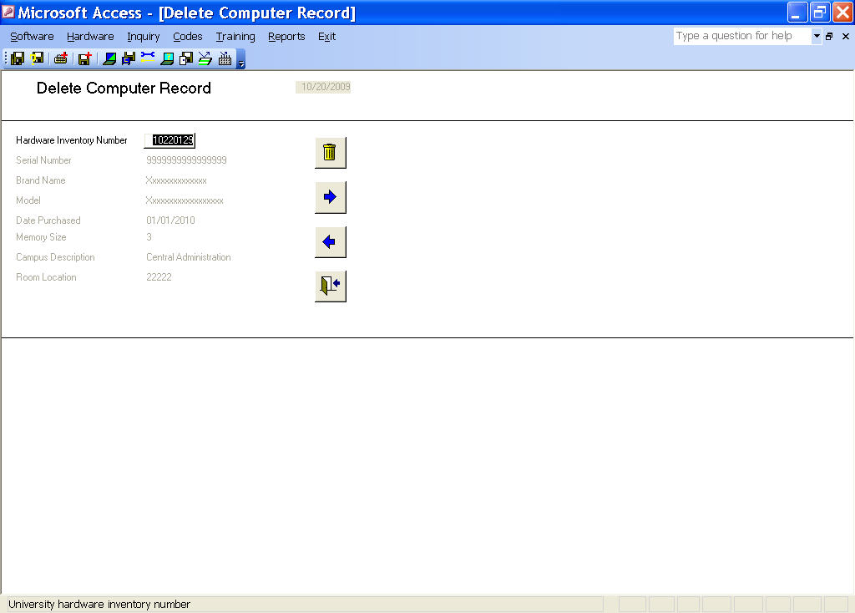
Figure 1

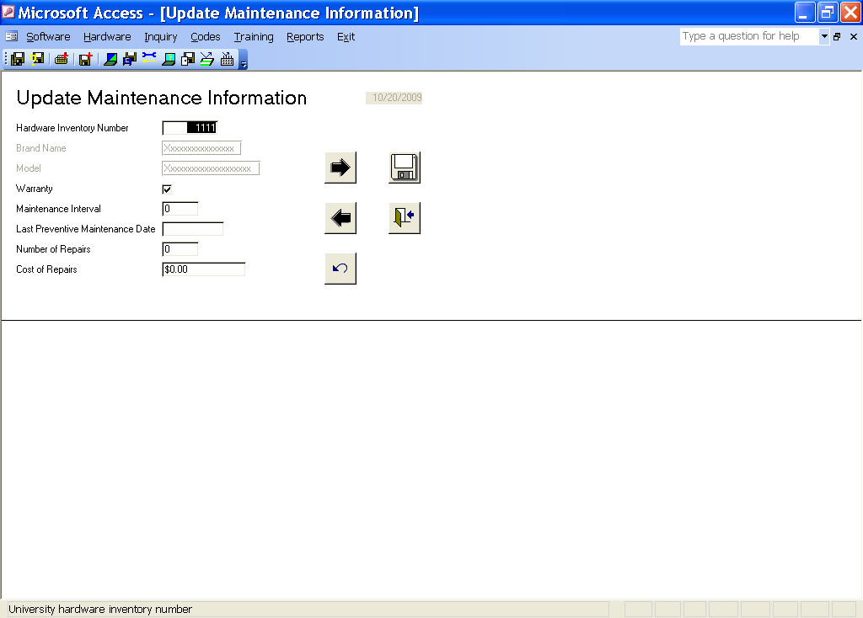
Figure 2

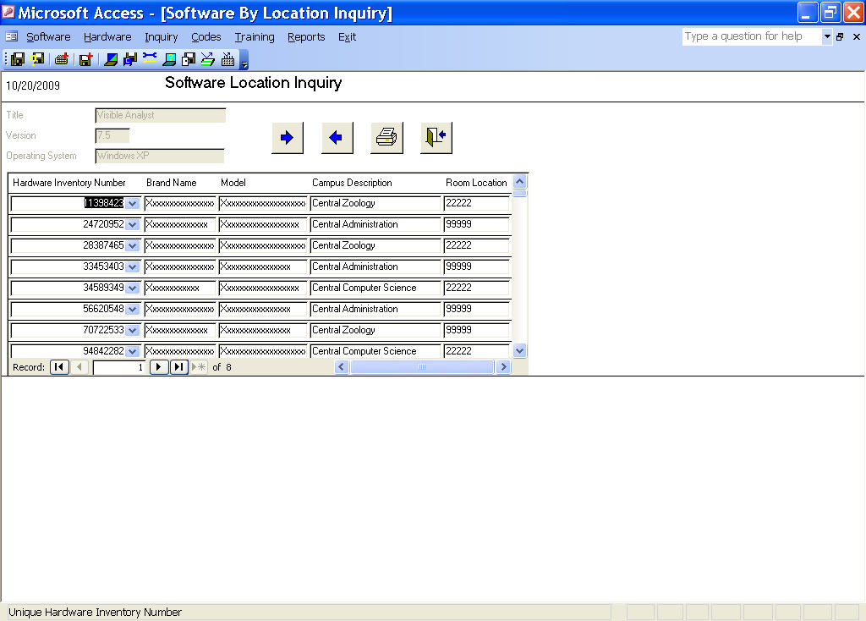
Figure 3

